CMPE314 – SOFTWARE ENGINEERING
Lab 2 Solution: Resource Allocation and Project Planning
Project: FitTrack – Personal Fitness Companion
Group 3/1: Tawfig Malik (22115813), Lahsen Aittjiou (22118897), Hassan Eihab HassanAli (22211935)

Part 1 – Resource allocation for sample Gantt
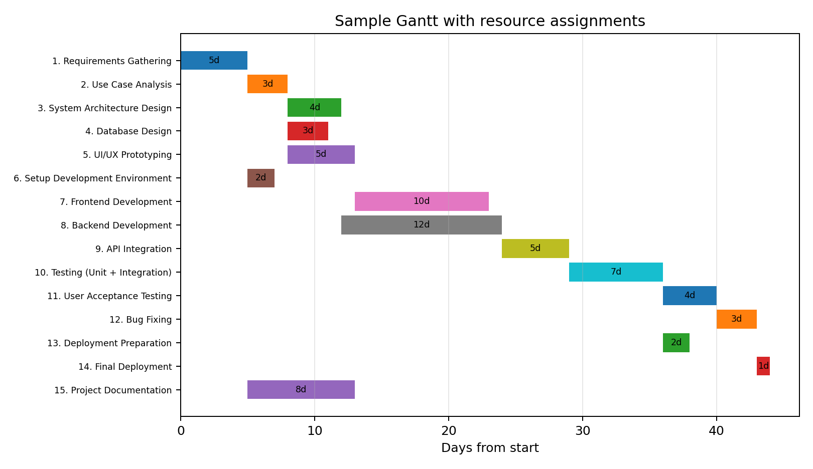
ID | Task | Resource(s)
1 | Requirements Gathering | Alex
2 | Use Case Analysis | Alex/Jamie
3 | System Architecture Design | Jamie
4 | Database Design | Jamie
5 | UI/UX Prototyping | Taylor
6 | Setup Development Environment | Casey
7 | Frontend Development | Taylor
8 | Backend Development | Jamie
9 | API Integration | Jamie/Taylor
10 | Testing (Unit + Integration) | Morgan
11 | User Acceptance Testing | Morgan
12 | Bug Fixing | Jamie/Taylor
13 | Deployment Preparation | Casey
14 | Final Deployment | Casey
15 | Project Documentation | Alex/Casey

Allocation explanation
Tasks were assigned according to role: Alex manages requirements and planning, Jamie handles backend, database and architecture, Taylor handles UI/frontend, Morgan handles testing, and Casey handles environment, deployment, and documentation support.

Part 2 – FitTrack term project plan
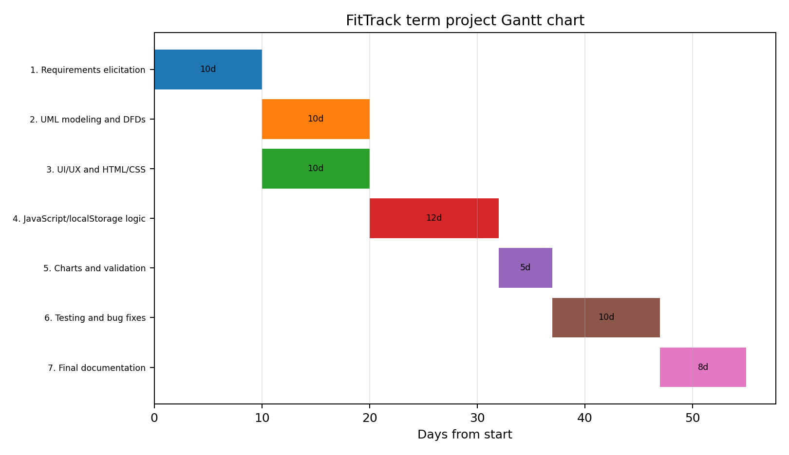
ID | Task | Duration | Dependencies | Assigned member
P1 | Requirements elicitation | 10 | - | All
P2 | UML modeling and DFDs | 10 | P1 | Hassan
P3 | UI/UX and HTML/CSS | 10 | P1 | Tawfig
P4 | JavaScript/localStorage logic | 12 | P2,P3 | Lahsen
P5 | Charts and validation | 5 | P4 | Lahsen
P6 | Testing and bug fixes | 10 | P5 | Lahsen/Hassan
P7 | Final documentation | 8 | P2,P6 | Hassan

